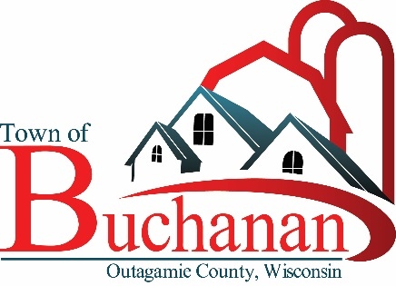 | “In the Spirit of Town Government”  TOWN OF BUCHANAN, OUTAGAMIE COUNTY, WI  MINUTES OF AD–HOC YARD WASTE COMMITTEE  TUESDAY, DECEMBER 11, 2018 AT 6:00 P.M.  BUCHANAN TOWN HALL, N178 COUNTY RD N, APPLETON, WI 54915

AGENDA

- CALL MEETING TO ORDER: Walsh called the meeting to order at 6:05 p.m.

- ROLL CALL & VERIFY PUBLIC NOTICE Public notice verified. Committee members present – Supervisor Reinke, Supervisor Walsh, Erdmann, & Walsh. Jensema arrived at 6:07 p.m. Also present was Town Administrator Brown.

- APPROVAL OF THE MINUTES OF FERUARY 27, 2018 AD-HOC YARD WASTE COMMITTEE
Motion by Erdmann/Supervisor Walsh to approve February 27, 2018 Minutes. Motion passed 5 to 0 by voice vote.

- NEW BUSINESS:

  - Collection Location for Yard Waste Materials
    - Site Plan – Layout of Site
The rear of Town Hall, which was the original location for a Maintenance Garage, was identified as the preferred location for a Yard Waste Transfer Station. The area would be 75’ x 30’ and there would be separate bays for materials – grass, leaves and brush. The blocks for each bay would be three high (2’ high/block).

Some items discussed were construction, security – cameras and process.

Also, a couple of questions considered were:
- How does the Town have residents pay for the enhanced service?
- How would the Town know residents are approved to dump?

Supervisor Walsh will contact Fredrickson to get a preliminary cost.

- FUTURE AGENDA ITEMS
Future meeting agenda/discussion items and possible action on future Ad Hoc Yard Waste Committee agenda, including specific items for inclusion on or exclusion from future agenda.

- ADJOURN: Motion by Reinke/Jensema to adjourn at 6:45 p.m. Motion carried 5 to 0 by voice vote.

Anthony Brown, Recording Secretary
Drafted: December 19, 2018

Motion to approve: Dated: _________________________, 2018

