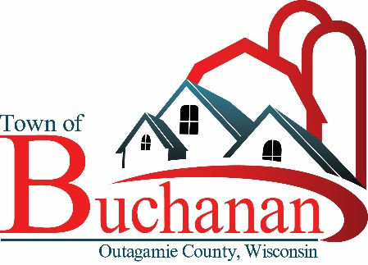 | “In the Spirit of Town Government”  TOWN OF BUCHANAN, OUTAGAMIE COUNTY, WI  PARKS COMMISSION MEETING MINUTES  4/5/2023 AT 6:30 P.M.  Panera, W3180 County Rd KK, Appleton WI 54915

- CALL MEETING TO ORDER Karley M. called the meeting to order at 6:30 p.m.

- ROLL CALL & VERIFY PUBLIC NOTICE: Public notice verified. Present – Meghan Huss, Tom Meyer, Karley Musil, Brian Regan, Justin Keen and Ken Jaworski from Cedar Corp.

- PUBLIC FORUM: No speakers

- MINUTES TO APPROVE
  - Park Commission Minutes from 3/22/23 Motion to Approve by Tom M. Second by Brian R. Carried by voice vote.

- PROJECT UPDATES/CORRESPONDENCE (For discussion only)
  - Ken from Cedar Corp attended to assist with the planning of the park layout
  - Discussion about the park layout, what makes the most sense to include in the different phases, as well as a potential time frame
  - What do we ultimately want to include in the park? Playground, open air shelter w/ picnic tables, water fountain, parking, 1 court slab with 3 pickleball courts and 1 half court basketball, paved path, sandbox, potential benches around perimeter of play area
  - Discussed best placement of park components based on drainage, current layout
  - Plan to remove current basketball court, put playground there. That will serve the dual purpose of having the planned paved path go past the playground, to improve accessibility, and keep the playground on a higher spot to improve drainage.
  - Convert the current tennis court to 3 pickleball courts and 1 half court basketball. Need to have someone evaluate if the current slab should be replaced or if it can be resurfaced. May be difficult to determine its suitability without knowing the base. Parking area located off Just About Lane-place culvert, fill in ditch and add several angle parking spots
  - Place shelter approx. 20’ x 30’ (and water fountain?) near parking.
  - Place drain tile based on drainage plan by Cedar Corp to improve drainage in park. May also need to add some fill.
  - This plan will leave a large area of green space available for potential future soccer goals or other uses.
  - Ken has contact through the Wisconsin Parks and Recreation Association and can get us information on vendors for shelters, playground equipment, sport courts.
  - Discussion on having a special meeting for neighborhood to have input on proposed park designs.
  - Discussion about fundraising for park improvements – can be to sponsor specific items like a bench or water fountain, or for the park in general. Ken has some experience with this. Ken recently did this with a different town, will send us more information.
  - Can be set up as a nonprofit 501c3
    - Pro – people like it better, guarantees money used for park
    - Con – takes longer to set up
    - Con – needs someone to administer
Can be through the town itself
Pro – faster to do
Pro – doesn’t need someone to administer
Con – people less likely to donate since they can’t guarantee it will go to the parks (goes into the general fund)

Other considerations: Landscaping? Security lighting? Security cameras?
What is the cost for Cedar Corp services to do the planning?
WI-MN Play Systems supplied the equipment in the Town Hall Park
Budget for this year is $195,000, includes drainage. If we don’t use the money this year, very possible we may lose the money.
Based on information received from Justin and Ken from Cedar Corp, new plan for phases:
- Phase 1 fall 2023 – Cedar Corp planning costs, pull out play equipment and basketball court (tennis court if needed), put in parking area w / gravel on top (will allow access for construction), do drainage / grading.
- Phase 2, spring 2024: Install playground, sport court, shelter, water fountain, shelter could be delayed depending on budget.

  - Met with Justin and Ken to go over future planning and deciding on next steps to possibly redesign park and location of equipment.
  - Looking to have drainage begin in 2023. Installation of equipment, possible movement of courts and overall layout in 2024.
  - Discussed getting public information and feedback opportunities for residents.

- UNFINISHED BUSINESS:
  - Determine more about starting 501C3 to generate revenue through donations – awaiting input from Town Board
  - Committee members to look through catalog from Landscape Structures to decide on items for park

- NEW BUSINESS:
  - Talk more on nonprofit money collection (501c3)

- ADJOURN Tom M. moved to adjourn at 7:25 pm, Brian R. Second. Carried by voice vote.
Other Future Meetings: April 20th, 2023 6:30 p.m.

Drafted April 7, 2023 by Megan Huss, Committee Member

