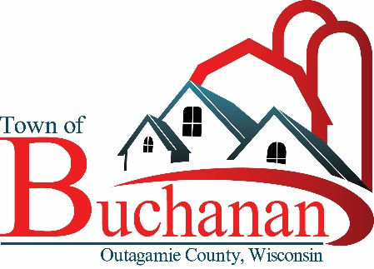 | “In the Spirit of Town Government”  TOWN OF BUCHANAN, OUTAGAMIE COUNTY, WI  NOTICE OF PARKS COMMISSION MEETING  Monday, November 13, 2023  5:30 Meeting at Town Hall  BUCHANAN TOWN HALL, N178 COUNTY RD N, APPLETON, WI 54915

AGENDA

- CALL MEETING TO ORDER

- ROLL CALL & VERIFY PUBLIC NOTICE

- PUBLIC FORUM
Members of the public are welcome to address the Park Commission. Individuals wishing to speak on any agenda item must sign in prior to the start of the meeting and may speak during the Public Comment Forum. The Public Comment Forum allows any member of the public to make their comments prior to the Park Commission discussion or action on an agenda related matter. Commentators must state name and address for the record. Individual comments are limited to no more than five minutes each. Once the public comment forum ends there will be no additional discussion from the audience. The Park Commission may suspend this rule if deemed necessary.

- MINUTES TO APPROVE
  - Park Commission Minutes from 10/9/2023

- UNFINISHED BUSINESS:

- Town Hall Park Progress Report
- Springfield Park Progress Report, Budget Update
- Fundraising Logistics Update
- Fundraising Materials Discussion
- CORP Update, ECWRPC

- FUTURE AGENDA ITEMS

- ADJOURN

Posted: Tom Meyer, Committee Member, 11/10/2023

-------------------------------------------------------------------------------------------------------------------------------------------------------------
Public Notice: Agendas are posted in the following locations: Town Hall bulletin board & Town website: www.townofbuchanan.org, Buchanan Festival Foods and Darboy Joint Sanitary District. 2015 Wisconsin Act 79 allows the publication of certain legal notices on an Internet site maintained by a municipality. This law allows these types of legal notices to be posted in one physical location in the jurisdiction (instead of three) if also placed on an Internet site maintained by the local government.

Special Accommodations: Requests from persons with disabilities who need assistance to participate in this meeting should be made to the Clerk’s Office at (920) 734-8599 with as much advance notice as possible.

Notice of Possible Quorum: A quorum of the Town Board, Board of Review, and/or Board of Appeals may be present at this meeting for the purpose of gathering information and possible discussion on items listed on this agenda. However, unless otherwise noted in this agenda, no official action by the Town Board, Board of Review, and/or Board of Appeals will be taken at this meeting.
-------------------------------------------------------------------------------------------------------------------------------------------------------------

