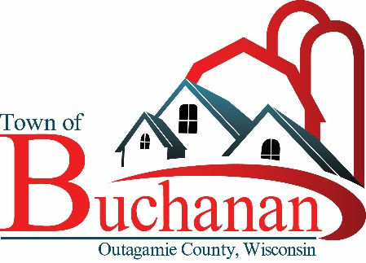 | “In the Spirit of Town Government”  TOWN OF BUCHANAN, OUTAGAMIE COUNTY, WI  PARKS COMMISSION MEETING MINUTES  Monday, November 13, 2023  5:30 PM Meeting at Town Hall  BUCHANAN TOWN HALL, N178 COUNTY RD N, APPLETON, WI 54915

- CALL MEETING TO ORDER – Meeting called to order at 5:30 by Tom Meyer

- ROLL CALL & VERIFY PUBLIC NOTICE – Present at the meeting were committee members Tom Meyer, Brian Regal, Karley Musil, and Meghan Huss. Also present was Town Administrator Michael Brown.

- PUBLIC FORUM - No members of the public were present.

- MINUTES TO APPROVE
  - Park Commission Minutes from 10/9/2023: Motion to approve by Karley Musil, second by Brian Regal. Carried by unanimous voice vote.

- UNFINISHED BUSINESS:

- Town Hall Park Progress Report – Unseasonably we weather delayed installation plans, but equipment has been delivered. There are plans in place to store the equipment over the winter if it cannot be installed until spring.
- Springfield Park Progress Report, Budget Update – Phase one work has been completed, and proposed budget amount for 2024 covers phase two conservative construction estimate from Cedar. Town Board to vote on the proposed budget on 11/21 meeting. Karley agreed to reach out to individual citizens to come and speak on behalf of the proposal at the Town Board meeting.
- Fundraising Logistics Update – Tom Meyer and Micheal Brown gave an update to the committee on a call with the town’s auditors and attorneys. The substance of the call was:
  - The Town will hold all funds, and come up with an accounting plan to track them.
  - A form should be used to collect information from donors, and that form should not specify how funds are to be applied unless the donor specifically requests that funds be applied in a certain manner. If that happens, make sure the request is specifically made in writing. The Town will then need to separately track those funds.
  - The Town would need to provide a receipt to the donor for tax purposes.
  - Consistent written materials should be used with all solicitations to avoid any miscommunication.
- Fundraising Materials Discussion – Karley Musil had drafted a donation form along with suggested donation amounts for naming rights of various items at Springfield Park. After discussion, suggestions were made for edits, which Karley would make. The updated forms would then be circulated to the Town’s attorney and auditor prior to being submitted for Town Board approval at the 11/21/23 meeting. Tom Meyer agreed to appear on behalf of the committee at the Town Board meeting to present the form and answer any questions.
- CORP Update, ECWRPC – Funds to engage ECWRPC are included in the 2024 draft budget for approval by the Town Board at the 11/21 meeting.

- FUTURE AGENDA ITEMS- Next meeting set at 5:30 PM on December 11, 2023.

- ADJOURN – Motion by Meghan Huss, second by Karley Musil. Motion carried by unanimous voice vote. Meeting adjourned at 6:13 PM.

Drafted: Tom Meyer, Committee Member, 11/14/2023

