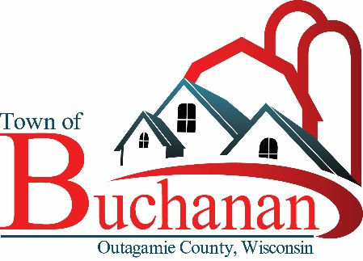 | “In the Spirit of Town Government”  TOWN OF BUCHANAN, OUTAGAMIE COUNTY, WI  PARKS COMMISSION MEETING MINUTES  Tuesday, February 13, 2024  5:30 Board Meeting at Town Hall  BUCHANAN TOWN HALL, N178 COUNTY RD N, APPLETON, WI 54915

Minutes

- CALL MEETING TO ORDER Meeting Called to Order at 5:30 by Tom Meyer

- ROLL CALL & VERIFY PUBLIC NOTICE Present from the committee were Tom Meyer, Karley Wardlow, Brian Regal, and Meghan Huss. Town Administrator Michael Brown was in attendance. Craig Moser and Rachel Roth were in attendance on behalf of ECWRPC. Member of the public who were present were:

  - Tiffany Siefelt, W3122 Creekview Lane.
  - Megan Fischer, N195 Springfield Ct
  - Jim Burke, N137 Maran Ave
  - Jennifer Rottier, W2876 Emons Rd

- PUBLIC FORUM
Tiffany Siefelt shared her thoughts on the various Springfield Park playground proposals, and shared the idea of combining options from different proposals.

Megan Fischer shared her thoughts on the various Springfield Park playground proposals, and in consultation with her children, voiced her support of having monkey bars that went in a straight line and adding more swings in lieu of a zipline.

Jim Burke shared his thoughts about the maintenance requirements of the various options, and shared his experience in dealing with several of the suppliers in the past.

Jennifer Rottier shared her thoughts on the various Springfield Park playground proposals.

- MINUTES TO APPROVE
  - Park Commission Minutes from 1/9/2024. Motion to approve by Karley Wardlow, Second by Brian Regal. Carried by voice vote.

- UNFINISHED BUSINESS:

- CORP Update, ECWRPC Craig Moser and Rachel Roth walked through the CORP update progress, and walked through the deliverables timeline to ensure completion of the update in 2024.
- Springfield Park Progress Report, Playground Selection After listening to input from the public, the committee decided to go back to Lee Recreation to see if they had the capacity to make two modifications to Proposal #2, and if so, to recommend its adoption to the Town Board. In the event Lee could not make those changes, a special meeting would be held to finalize a board recommendation. A motion to that effect was made by Meghan Huss, and seconded by Karley Wardlow. Carried by voice vote.
- Fundraising Update and Planning No formal update, but looking at options for a town festival during the summer.
- Earth Day Clean Up on 4/22/24. Need availability for a meeting with Nichole Nielsen to coordinate. Michael Brown informed us that the committee will be updated on the Earth Day Cleanup at our March meeting.

- FUTURE AGENDA ITEMS - None

- ADJOURN- Motion to Adjourn at 6:42, Made by Karley Wardlow. Seconded by Meghan Huss. Passed by voice vote.

Drafted: Tom Meyer, Committee Member, 3/11/2024

-------------------------------------------------------------------------------------------------------------------------------------------------------------

