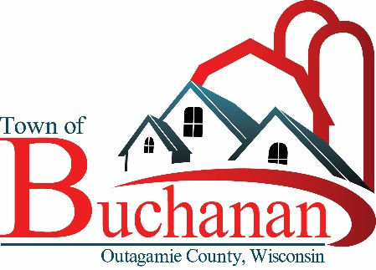 | “In the Spirit of Town Government”  TOWN OF BUCHANAN, OUTAGAMIE COUNTY, WI  PARKS COMMISSION MEETING MINUTES  Tuesday, March 12, 2024  5:30 Board Meeting at Town Hall  BUCHANAN TOWN HALL, N178 COUNTY RD N, APPLETON, WI 54915

Minutes

- CALL MEETING TO ORDER: Called to order by Tom Meyer at 5:30

- ROLL CALL & VERIFY PUBLIC NOTICE: Present were committee members Tom Meyer, Meghan Huss, Karley Wardlow, and Brian Regal. Also present were Dennis Jandrey and Michael Brown.

- PUBLIC FORUM No members of the public were present.

- MINUTES TO APPROVE
  - Park Commission Minutes from 2/13/2024 – Motion to Approve by Karley Wardlow, Second by Meghan Huss. Motion carried by voice vote.

- UNFINISHED BUSINESS:

- Earth Day Clean Up on 4/22/24 – Dennis Jandrey will lead clean up of the parks and Main Street Pond trail on April 20th. Committee members will help organize volunteers.
- CORP Update, ECWRPC – The EPWRPC survey language was updated and finalized. Micheal Brown was tasked with getting updates to EPWRPC so the survey could go live by April 1. Michael also walked through the survey and mapping tools that will be available to residents.
- Springfield Park Progress Report – The Board approved the playground recommendation, and is moving ahead with the plan to put phase two out for bid in April with an anticipated May award.
- Fundraising Update and Planning – Hickory Park updates proposed by a soccer club which as approached the board.

- FUTURE AGENDA ITEMS

- ADJOURN – Motion by Karley Wardlow. Second by Brian Regal. Approved by voice vote. Meeting adjourned at 6:09 PM.

Drafted: Tom Meyer, Committee Member 4/4/2024

