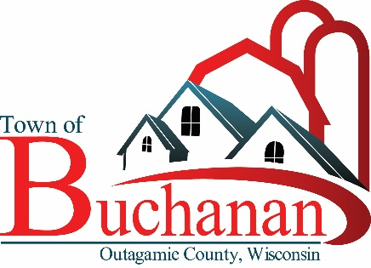 | “In the Spirit of Town Government”  TOWN OF BUCHANAN, OUTAGAMIE COUNTY, WI  NOTICE OF BOARD OF REVIEW MEETING  TUESDAY, MAY 18, 2021 AT 5:50 P.M.  BUCHANAN TOWN HALL, N178 COUNTY RD N, APPLETON, WI 54915
AGENDA

- CALL MEETING TO ORDER

- PLEDGE OF ALLEGIANCE

- ROLL CALL & VERIFY PUBLIC NOTICE

- MOTION TO OFFICEIALLY OPEN BOARD OF REVIEW

- MOTION TO ADJOURN BOARD OF REVIEW TO AUGUST 18, 2021 FROM 6:00 P.M. TO 8:00 P.M.

Open Book will be held on July 12th from 11:00 a.m. to 2:00 p.m. and 3:00 p.m. to 6:00 p.m. Also, July 13th from 9:00 a.m. to Noon and 1:00 p.m. to 3:00 p.m.at the Town Hall or via the telephone with Accurate Appraisal.

- MOTION TO CLOSE THE BOARD OF REVIEW

Posted: May 14, 2021

Cynthia, Sieracki, Clerk/Treasurer
Town of Buchanan

-------------------------------------------------------------------------------------------------------------------------------------------------------------
Public Notice: Agendas are posted in the following locations: Town Hall bulletin board, Town website: www.townofbuchanan.org. Buchanan Festival Foods and Darboy Joint Sanitary District.

Special Accommodations: Requests from persons with disabilities who need assistance to participate in this meeting should be made to the Clerk’s Office at (920) 734-8599 with as much advance notice as possible.

Notice of Possible Quorum: A quorum of the Plan Commission, Board of Review, and/or Board of Appeals may be present at this meeting for the purpose of gathering information and possible discussion on items listed on this agenda. However, unless otherwise noted in this agenda, no official action by the Plan Commission, Board of Review, and/or Board of Appeals will be taken at this meeting.
-------------------------------------------------------------------------------------------------------------------------------------------------------------

