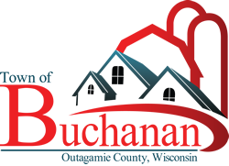 | “In the Spirit of Town Government”  TOWN OF BUCHANAN, OUTAGAMIE COUNTY, WI  NOTICE OF POSSIBLE QUORUM  PUBLIC INVOLVEMENT MEETING  AMERICAN RESCUE PLAN ACT FUNDS  TUESDAY, SEPTEMBER 7, 2021 FROM 6:00 P.M. – 7:00 P.M.  BUCHANAN TOWN HALL, N178 COUNTY RD N, APPLETON, WI 54915

NOTICE OF POTENTIAL GATHERING OF A QUORUM OF
THE TOWN OF BUCHANAN BOARD OF SUPERVISORS

NOTICE IS HEREBY GIVEN that the members of the Town of Buchanan Town Board may be present at a Public Involvement meeting for American Rescue Plan Act Funds be held on Tuesday, September 7, 2021 from 6:00 p.m. until 7:00 p.m. at the Town of Buchanan Town Hall located at N178 County Road N, Appleton, WI 54915. Although no formal action will be taken nor matters of Town business discussed, a quorum of the Board may be gathered for the event.

Cynthia Sieracki, Clerk
Posted: 8/31/2021

