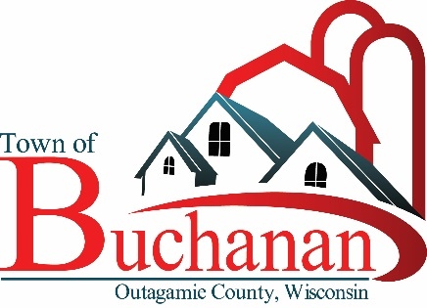 | “In the Spirit of Town Government”  TOWN OF BUCHANAN, OUTAGAMIE COUNTY, WI  MINUTES OF BOARD OF REVIEW  TUESDAY, MAY 18, 2021 AT 5:50 P.M.  BUCHANAN TOWN HALL, N178 COUNTY RD N, APPLETON, WI 54915

Minutes
Town of Buchanan
Board of Review
Tuesday, May 18, 2021 – 5:50 p.m.

At 5:50 p.m. on Tuesday, May 18, 2021 Town Chairperson Sprangers called the Board of Review meeting to order. Members present were Lawrence, Reinke, Kavanaugh, and Sprangers. Public notice was verified. Motion by Kavanaugh/Lawrence to officially open the Board of Review at 5:50 p.m. Motion carried 4 to 0.

The Chairperson then immediately adjourned the meeting to such a date as when the assessment roll is completed. Motion by Lawrence/Reinke to adjourn the meeting and hold the Board of Review on August 18, 2021 from 6:00 p.m. to 8:00 p.m. at the Town Hall. Motion carried 4 to 0. Sprangers noted that Open Book will be held on July 12th from 11:00 a.m. to 2:00 p.m. and 3:00 p.m. to 6:00 p.m. Also, July 13th from 9:00 a.m. to Noon and 1:00 p.m. to 3:00 p.m. at the Town Hall or via the telephone with Accurate Appraisal. Motion by Lawrence/Reinke to close the Board of Review meeting at 5:55 p.m. Motion carried 4 to 0.

Cynthia Sieracki, Clerk
Town of Buchanan
Dated: 5/19/2021

