September 14, 2021

**RE: 2022 Roadway Construction – Contract A22**

Dear Property Owner,

At the August 17, 2021 Town Board meeting the Board approved the following roads for construction in 2022:

Creekview Lane, Speel School Road to Eisenhower Drive

Westowne Court

Pinewood Court

Pinecrest Court

You are receiving this notification because you are listed as owning a property located on these roads. More details, such as schedule, will be known closer to the date of the project in 2022. You will be notified by mail of all public information meetings.

If you have any questions, please contact me at (920) 734-8599.

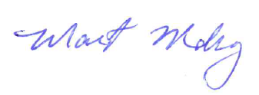Sincerely,

Maggie Mahoney

Town Administrator

cc: Thad Majkowski, Town Engineer