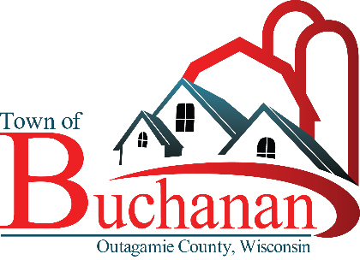

**Calendar for 2023 Budget Adoption**

*(Subject to change as needed)*

**Tuesday, June 21, 2022 - Town Board Meeting**

* Town Administrator distributes 2023 Budget Adoption Calendar.

**Tuesday, July 19, 2022 – Town Board Meeting**

* Town Administrator presents five-year forecast.
* Discuss key assumptions for budget such as tax levy, general obligation debt, compensation, long-range financial planning for Capital Improvement Plan.

**Wednesday, July 20, 2022 – Budget Schedule & Memorandum Distributed**

* Budget documents and memorandum distributed to key staff and contractors.
* Communicate key priorities of the Town Board and overall budget outlook.
* Communicate budget priorities and spending parameters of Town Administrator.
* Discuss instructions and procedures for preparing departmental/divisional budgets.
* Discuss internal/department meeting schedule with Administrator to review budget proposals.
* Distribute line-item and capital project request forms.

**Wednesday, August 10, 2022 – Department Requests & Capital Improvement Plan (CIP) Requests due to Town Administrator**

* Individual budget meetings to review/revise requests scheduled August 25th to September 2nd with Town Administrator.

**August 25 to September 2,2022 – Budget Meetings with Town Administrator to Review Budget Requests**

**Tuesday, September 20, 2022 – Town Board Meeting**

* Town Engineer presents draft 10 Year Road & Drainage Plan
* Town Administrator presents recommended compensation plan for employees; seeks Town Board direction on proposed compensation amounts.

**Thursday, October 6, 2022 – Special Town Board Meeting immediately following Utility Commission Meeting**

* Town Administrator presents 2023-2027 Capital Improvement Plan.
* Town Administrator presents updated 10 Year Road & Drainage Plan.

**Thursday, October 20, 2022 – Special Town Board Meeting**

* Presentation of comprehensive 2023 executive budget, including general overview power-point presentation.
* Specific funds/program areas discussed include: general government, public safety, public works, culture, recreation, conservation and development, capital projects, debt service and long-term borrowing, revenues.
* Specific funds/program areas discussed include: special charges (garbage/recycling, street lighting, stormwater utility, etc.).
* Town Board adopts resolutions establishing an amended fees and charges schedule and special charge rates for 2023.
* Town Board finalizes 2023 draft budget to be presented at November public hearing.

**Thursday, November 3, 2022 – Budget Public Hearing & Special Town Meeting**

* A Public Hearing in accordance with State Statute is held; staff provides comprehensive power point presentation of proposed budget.
* Town Electors establish, in accordance with State Statute, compensation of elected Town officials to begin in April 2023.
* Town Electors adopt, in accordance with State Statute, the 2022 town tax levy to be paid in 2023.

**Tuesday, November 15, 2022 –Town Board Meeting**

* Town Board Approves Resolution adopting the 2023 Fiscal Year Budget.